

**숙제 5 A star 알고리즘으로 경로 찾기**

**과목명 게임프로그래밍**

**담당교수님 김상철교수님**

**제출일 20220621**

**전공 컴퓨터전자시스템**

**학번 201904458**

**이름 이준용**

1. Patrol.cs와 PatrolCoroutines.cs 라는 스크립트를 새로 만들었습니다. 위의 스크립트는 Character가 mark를 바라 보면서 이동하게 만들어주는 스크립트 입니다.

Patrol.cs

using UnityEngine;

public class Patrol : MonoBehaviour

{

//This array is used to set which points are the waypoints

    //public GameObject[] wayPoints;

    public Transform[] waypoints;

    private int _currentWaypointIndex = 0;

    private float _speed = 2f;

    private float _waitTime = 1f; // in seconds

    private float _waitCounter = 0f;

    private bool _waiting = false;

    //public Transform goal;

    private void Update()

    {

        if (_waiting)

        {

            _waitCounter += Time.deltaTime;

            if (_waitCounter < _waitTime)

                return;

            _waiting = false;

        }

        Transform wp = waypoints[_currentWaypointIndex];

        if (Vector3.Distance(transform.position, wp.position) < 0.01f)

        {

            transform.position = wp.position;

            _waitCounter = 0f;

            _waiting = true;

            _currentWaypointIndex = (_currentWaypointIndex + 1) % waypoints.Length;

        }

        else

        {

            transform.position = Vector3.MoveTowards(transform.position, wp.position, _speed * Time.deltaTime);

            transform.LookAt(wp.position);

        }

    }

}

PatrolCoroutines.cs

using System.Collections;

using UnityEngine;

public class PatrolCoroutines : MonoBehaviour

{

    public Transform[] waypoints;

    private int _currentWaypointIndex = 0;

    private float _speed = 2f;

    private float _waitTime = 1f; // in seconds

    private Coroutine _prevCoroutine;

    private void Start()

    {

        _prevCoroutine = StartCoroutine(_MovingToNextWaypoint());

    }

    private IEnumerator _MovingToNextWaypoint()

    {

        Transform wp = waypoints[_currentWaypointIndex];

        while (Vector3.Distance(transform.position, wp.position) > 0.01f)

        {

            transform.position = Vector3.MoveTowards(transform.position, wp.position, _speed * Time.deltaTime);

            yield return null;

        }

        transform.position = wp.position;

        yield return new WaitForSeconds(_waitTime);

        _currentWaypointIndex = (_currentWaypointIndex + 1) % waypoints.Length;

        StopCoroutine(_prevCoroutine);

        _prevCoroutine = StartCoroutine(_MovingToNextWaypoint());

    }

}

Seek.cs

using System.Collections;

using System.Collections.Generic;

using UnityEngine;

public class Seek : MonoBehaviour

{

    public float Mass = 15;

    public float MaxVelocity = 3;

    public float MaxForce = 15;

    private Vector3 velocity;

    public Transform target;

    private void Start()

    {

        UnityEngine.AI.NavMeshAgent agent = GetComponent<UnityEngine.AI.NavMeshAgent> ();

        agent.destination = target.position;

        velocity = Vector3.zero;

    }

    private void Update()

    {

        var desiredVelocity = target.transform.position - transform.position;

        desiredVelocity = desiredVelocity.normalized * MaxVelocity;

        var steering = desiredVelocity - velocity;

        steering = Vector3.ClampMagnitude(steering, MaxForce);

        steering /= Mass;

        velocity = Vector3.ClampMagnitude(velocity + steering, MaxVelocity);

        transform.position += velocity * Time.deltaTime;

        transform.forward = velocity.normalized;

        Debug.DrawRay(transform.position, velocity.normalized * 2, Color.green);

        Debug.DrawRay(transform.position, desiredVelocity.normalized * 2, Color.magenta);

    }

}

WalkToGoal.cs

using System.Collections;

using System.Collections.Generic;

using UnityEngine;

using UnityEngine.AI;

public class WalkToGoal : MonoBehaviour {

    public Transform goal;

    // Use this for initialization

    void Start () {

        NavMeshAgent agent = GetComponent<NavMeshAgent> ();

        GameObject[] targets = GameObject.FindGameObjectsWithTag("destination");

        // GameObject randomTarget = targets [Random.Range(0, targets.length())];

        agent.destination=goal.position;

    }

    // Update is called once per frame

    void Update () {

    }

}

Waypoint.cs

using System.Collections;

using System.Collections.Generic;

using UnityEngine;

using UnityEngine.AI;

public class Waypoint : MonoBehaviour

{

//  public List<Node> GetNeighbours(Node node)

// {

//     List<Node> neighbours = new List<Node>();

//     int[,] temp = { { 0, 1 }, { 1, 0 }, { 0, -1 }, { -1, 0 } };

//     bool[] walkableUDLR = new bool[4];

//     //상하좌우의 노드 먼저 계산

//     for (int i = 0; i < 4; i++)

//     {

//         int checkX = node.gridX + temp[i, 0];

//         int checkY = node.gridY + temp[i, 1];

//         if (checkX >= 0 && checkX < (int)gridWorldSize.x && checkY >= 0 && checkY < (int)gridWorldSize.y)

//         {

//             if (grid[checkX, checkY].walkable)

//                 walkableUDLR[i] = true;

//             neighbours.Add(grid[checkX, checkY]);

//         }

//     }

//     //대각선의 노드를 계산

//     for (int i = 0; i < 4; i++)

//     {

//         if (walkableUDLR[i] || walkableUDLR[(i + 1) % 4])

//         {

//             int checkX = node.gridX + temp[i, 0] + temp[(i + 1) % 4, 0];

//             int checkY = node.gridY + temp[i, 1] + temp[(i + 1) % 4, 1];

//             if (checkX >= 0 && checkX < (int)gridWorldSize.x && checkY >= 0 && checkY < (int)gridWorldSize.y)

//             {

//                 neighbours.Add(grid[checkX, checkY]);

//             }

//         }

//     }

//     return neighbours;

// }

    public List<GameObject> neighbors;

    public Waypoint previous

    {

        get;

        set;

    }

    public float distance

    {

        get;

        set;

    }

    void OnDrawGizmos()

    {

        if (neighbors == null)

            return;

        Gizmos.color = new Color (0f, 0f, 0f);

        foreach(var neighbor in neighbors)

        {

            //print("Draw Line");

            if (neighbor != null)

                Gizmos.DrawLine (transform.position, neighbor.transform.position);

        }

    }

}

WayPointAI.cs

using System.Collections;

using System.Collections.Generic;

using UnityEngine;

using UnityEngine.AI;

//using UnityEngine;

//using System.Collections;

public class WayPointAI : MonoBehaviour

{

    //This array is used to set which points are the waypoints

    public GameObject[] wayPoints;

    //Speed and distance. Distance is used to determine how close you

    //want the object to get before going to next point.

    public float spd;

    public float distance;

    //Holds the current waypoint it is going to

    public int currentPoint;

    private bool change = false;

    //Holds the position of the waypoint it's heading towards.

    private Vector3 targetPosition;

    // Use this for initialization

    void Start()

    {

        //Sets  the first waypointPosition

        targetPosition = wayPoints[currentPoint].transform.position;

    }

    // Update is called once per frame

    void Update()

    {

        //Checks if the distance from the object to the way point is less than distance given

        //Once true it will increment to the next point.

        if (Vector3.Distance(transform.position, targetPosition) < distance && !change)

        {

            nextPoint();

        }

        else

        {

            float dir = 0;

            //Moving and turning

            //Gets the direction to face

            dir = -Mathf.Atan2(transform.position.z - targetPosition.z, transform.position.x - targetPosition.x) - 90 * Mathf.Deg2Rad;

            //Draws the line to show where the object is going.

            Vector3 sp = new Vector3(transform.position.x,

                1, transform.position.z);

            //Debug.DrawRay(transform.position, new Vector3(Mathf.Sin(dir), 0, Mathf.Cos(dir)) * 20);

            Debug.DrawRay(sp, new Vector3(Mathf.Sin(dir), 0, Mathf.Cos(dir)) * 2, Color.black);

            //Rotates the object towards to the waypoint.

            transform.rotation = Quaternion.AngleAxis(dir * Mathf.Rad2Deg, Vector3.up);

            //Moves the object forward

            transform.Translate(Vector3.forward * spd * Time.deltaTime);

            change = false;

        }

    }

    private void nextPoint()

    {

        print("nextPoint()");

        //Checks to see if it reached the max waypoint possible

        if (currentPoint >= wayPoints.Length - 1)

            //If true sets it to 0 so array doesn't go out of bounds.

            currentPoint = 0;

        else

            currentPoint++;

        //Sets the the targetPosition to the next waypoint.

        targetPosition = wayPoints[currentPoint].transform.position;

        change = true;

    }

}

// void FindPath()

// {

//     List<Node> openSet = new List<Node>();          //OPEN

//     HashSet<Node> closedSet = new HashSet<Node>();  //CLOSE

//     openSet.Add(start);                             //OPEN에 시작노드 저장

//     while (openSet.Count > 0)

//     {

//         Node currentNode = openSet[0];

//         //OPEN에 fCOST가 가장 작은 노드를 찾기

//         for(int i = 1; i<openSet.Count; i++)

//         {

//             if (openSet[i].fCost < currentNode.fCost || openSet[i].fCost == currentNode.fCost && openSet[i].hCost < currentNode.hCost)

//             {

//                 currentNode = openSet[i];

//             }

//         }

//         openSet.Remove(currentNode);

//         closedSet.Add(currentNode);

//         //도착지점에 오면 종료

//         if (currentNode == end)

//         {

//             return;

//         }

//         if (currentNode != start)

//             currentNode.ChangeColor = Color.Lerp(Color.cyan, Color.white, 0.2f);

//         //이웃 노드를 검색

//         foreach (Node neighbour in grid.GetNeighbours(currentNode))

//         {

//             //이동불가 노드 이거나 이미 검색한 노드 제외

//             if (!neighbour.walkable  || closedSet.Contains(neighbour))

//             {

//                 continue;

//             }

//             int newMovementCostToNeighbour = currentNode.gCost + GetDistance(currentNode, neighbour);

//             if (newMovementCostToNeighbour < neighbour.gCost || !openSet.Contains(neighbour))

//             {

//                 neighbour.gCost = newMovementCostToNeighbour;

//                 neighbour.hCost = GetDistance(neighbour, end);

//                 neighbour.parent = currentNode;

//                 if (!openSet.Contains(neighbour))

//                 {

//                     openSet.Add(neighbour);

//                     if (neighbour.walkable && !neighbour.end)

//                         neighbour.ChangeColor = Color.Lerp(Color.green, Color.white, 0.2f);

//                 }

//             }

//         }

//     }

// }

// //노드간의 거리 계산

// int GetDistance(Node nodeA, Node nodeB)

//     {

//         int dstX = Mathf.Abs(nodeA.gridX - nodeB.gridX);

//         int dstY = Mathf.Abs(nodeA.gridY - nodeB.gridY);

//         if (dstX > dstY)

//             return 14 * dstY + 10 * (dstX - dstY);

//         return 14 * dstX + 10 * (dstY - dstX);

//     }

실행화면

1. 게임 시작전 화면

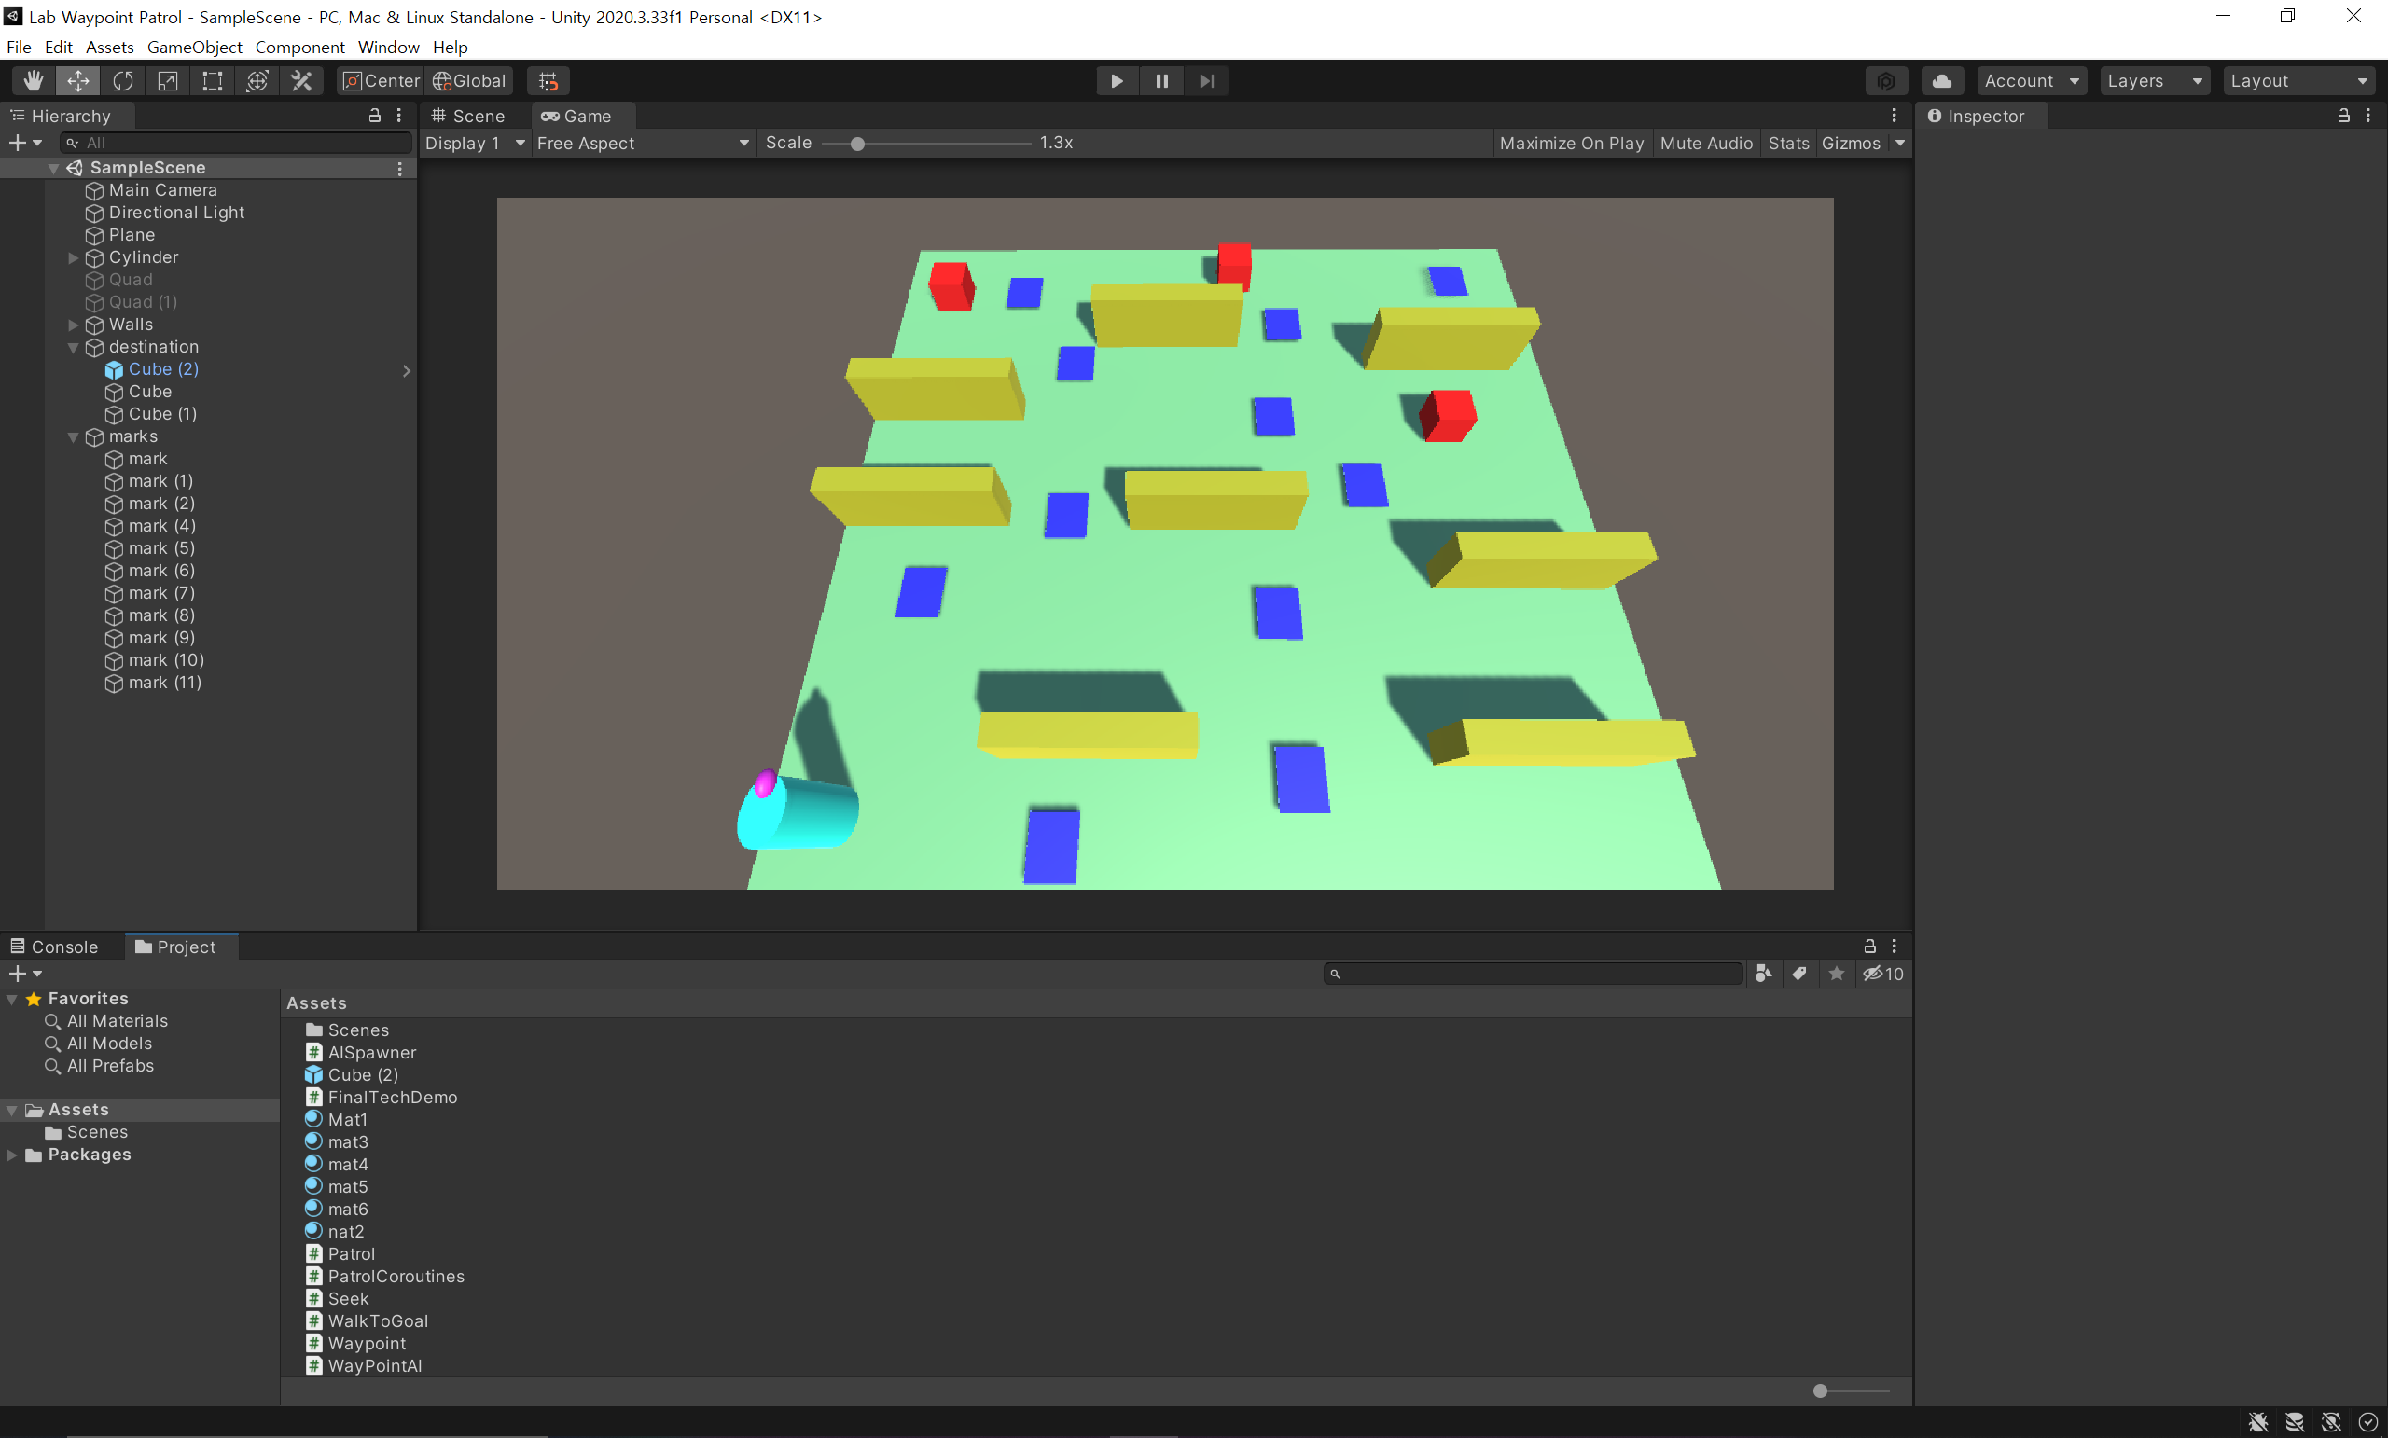

1. Cube라는 GameObject에 이동하는 장면

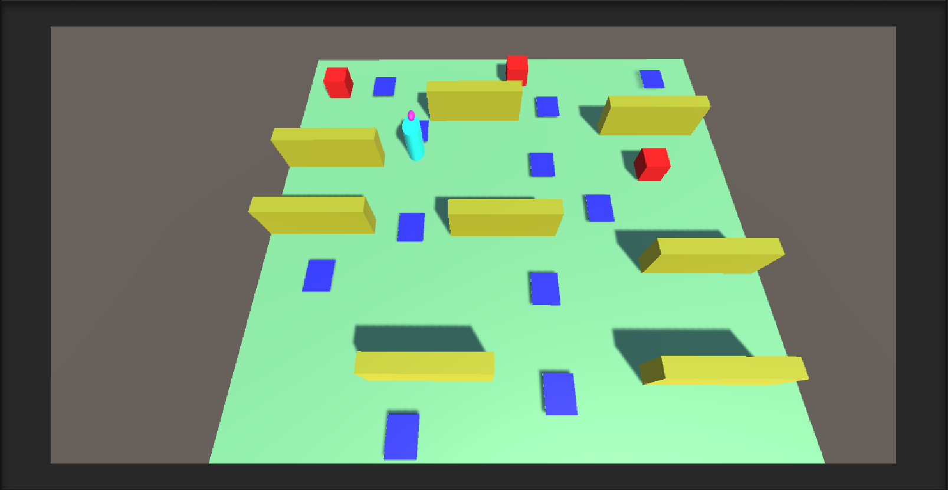

1. Cube에 도착한 모습

감사합니다.